RESTAURANT REVIEW APP
@CREATIVITY THINK (9483175986/7019689991)

ABSTRACT:
The Restaurant Review App is a web-based platform designed to facilitate dining discovery and provide a reliable review system for restaurants. Users can browse restaurants, submit reviews and ratings, follow top reviewers, and engage with community comments. Administrators manage restaurant listings, moderate reviews and comments, push featured picks, and analyze platform data through dashboards. Developed using Django and Django REST Framework for backend operations and React with Axios and Chart.js for frontend interaction, the system ensures efficient, scalable, and secure review management with interactive analytics..

INTRODUCTION OF THE PROJECT:
With the growth of food discovery platforms and online restaurant reviews, users require a reliable and structured system to share and access dining experiences. Traditional review systems may lack moderation, analytics, and real-time insights. The Restaurant Review App addresses these issues by providing a centralized platform where users can post, read, and interact with restaurant reviews, while administrators maintain quality control and gain operational insights. The system combines backend validation, secure API handling, and a responsive frontend to deliver a seamless user experience..

PROJECT OBJECTIVES:

• Provide a platform for users to browse and review restaurants.
• Enable posting of reviews and ratings with community interaction.
• Implement comment moderation to ensure content quality.
• Allow administrators to add and manage restaurant listings.
• Provide dashboards with analytics for user engagement and review trends.
• Highlight featured restaurants and top reviewers.
• Support secure user authentication and access control.
• Offer scalable backend APIs for future enhancements.

PROBLEM OF THE STATEMENT:
Many existing restaurant review platforms suffer from unmoderated content, inaccurate ratings, and lack of actionable analytics for administrators. Users find it challenging to identify top-rated restaurants and reliable reviews, while admins struggle to maintain quality and monitor trends. The Restaurant Review App solves these problems by offering structured review submission, comment moderation, analytics dashboards, and featured recommendations to enhance user engagement and provide trustworthy dining insights..

MOTIVATION OF THE PROJECT:
• To provide users with a reliable platform for discovering and rating restaurants.
• To enable administrators to manage content effectively and maintain review quality.
• To support community interaction with moderated comments and reviews.
• To highlight top reviewers and featured restaurants for better user guidance.
• To provide data-driven insights through analytics dashboards.
• To deliver a scalable and secure web application for dining enthusiasts.

BLOCK DAIGRAM OF PROJECT:

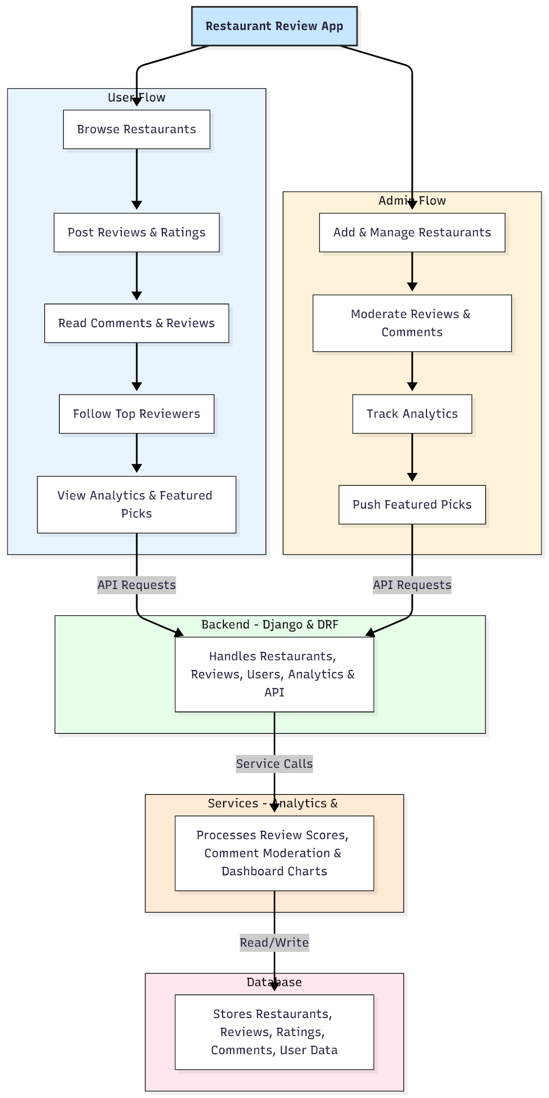

WORKING OF THE PROJECT:
Users start by registering or logging into the system. They browse restaurants, submit reviews and ratings, read other users’ comments, and follow top reviewers. The backend validates and stores reviews, updates ratings, and ensures moderation of inappropriate content. Administrators add and manage restaurant listings, moderate reviews and comments, track analytics for user engagement and review trends, and highlight featured restaurants and top reviewers. All user and admin interactions pass through secure Django REST APIs, with data stored in a SQL database. Chart.js is used to render analytics and visual insights on dashboards..

SOFTWARE REQUIREMENT:
- Backend:
  - Python 3.x
  - Django
  - Django REST Framework
  - SQLite/PostgreSQL
- Frontend:
  - Node.js and npm
  - React.js
  - Axios
- Development Tools:
  - Visual Studio Code
  - Postman (for testing APIs)
  - Git/GitHub (for version control)
- Server/Deployment (Optional):
  - Gunicorn, Nginx, or Heroku/AWS for hosting

ADVANTAGES OF THE PROJECT:

• Centralized platform for restaurant discovery and reviews.
• Moderation ensures quality and reliability of reviews.
• Analytics dashboard for user engagement and restaurant performance.
• Highlights top reviewers and featured restaurants for better guidance.
• Secure authentication and user management.
• Easy-to-use interface for both users and administrators.
• Scalable architecture suitable for multiple regions or restaurant categories.
• Encourages community interaction and reliable feedback.

APPLICATIONS OF THE PROJECT:
• Restaurant rating and discovery platforms.
• Food blogging and review websites.
• Local dining directories.
• Hospitality management and tourism review systems.
• Mobile or web-based dining recommendation apps.

REFERENCES:

- Django REST Framework Documentation — Django Software Foundation. Django Documentation. Available: https://docs.djangoproject.com/
- Django REST Framework. DRF Documentation. Available: https://www.django-rest-framework.org/
- React. React Official Documentation. Available: https://reactjs.org/docs/getting-started.html
- Redux. Redux Documentation. Available: https://redux.js.org/introduction/getting-started
- PostgreSQL Global Development Group. PostgreSQL Documentation. Available: https://www.postgresql.org/docs/
- MySQL. MySQL Reference Manual. Available: https://dev.mysql.com/doc/
- Git. Git Documentation. Available: https://git-scm.com/doc
- Node.js. Node.js Documentation. Available: https://nodejs.org/en/docs/
- Axios. Axios Documentation. Available: https://axios-http.com/docs/intro
- Socket.io Documentation – https://socket.io/docs/

